1. Creating an EC2 and launching:

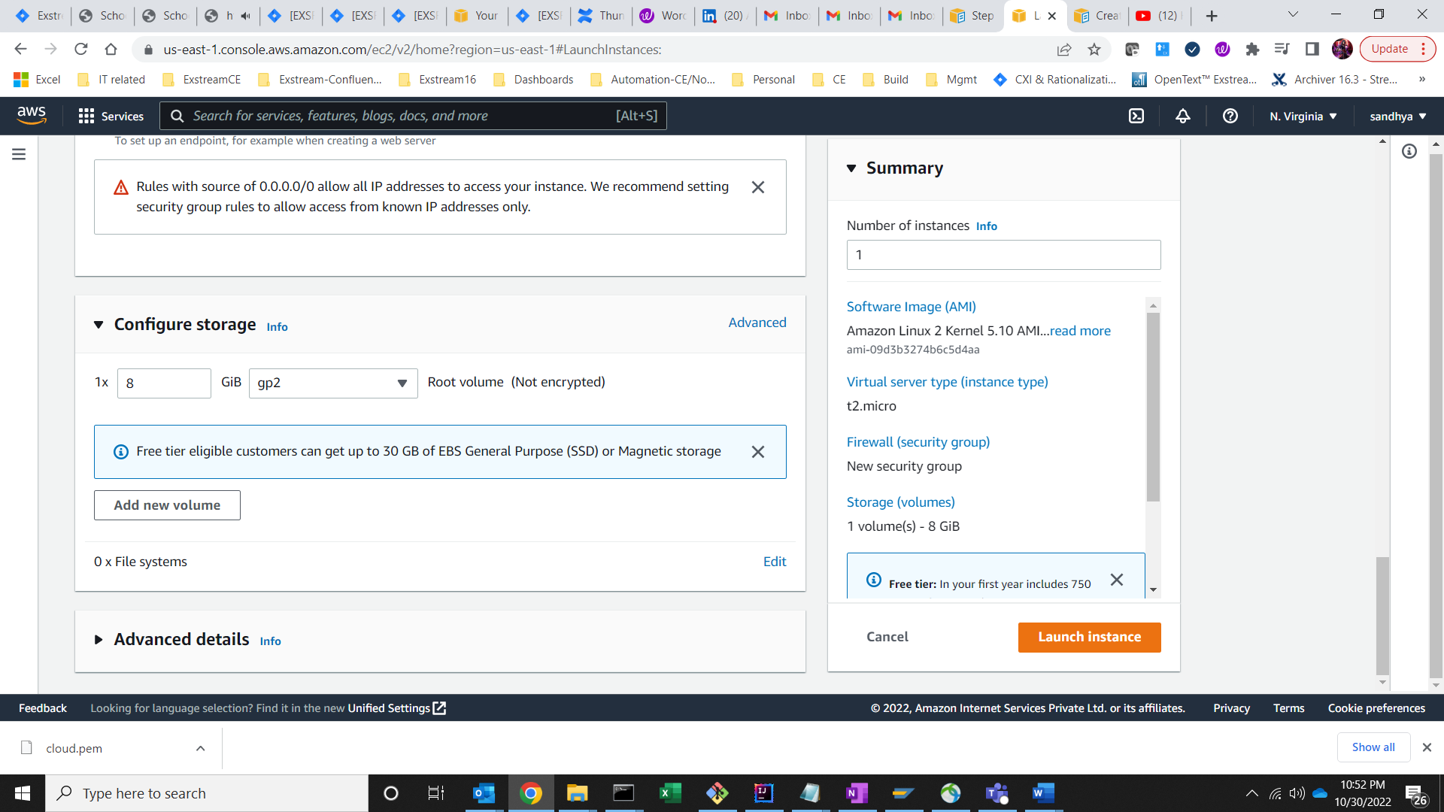

1. Create an EC2 instance

1. EC2 instance is created and is running

1. Connected to EC2 instance

2. Creation of EBS – Elastic Block Store

* Create a Machine A
* Create a volume “Storage”
* Attach the volume “Storage” to Machine A
* Logon on to Machine A then make a file system and mount the file system
  + lsblk -> List all file systems
  + fdisk -l -> to get all disk information
  + Create a directory – mkdir <name>
* mkfs -t xfs <disk>
* Mount -t xfs <disk> <dirname>
* Create some files in the file system
* Umount the file system
* Detach the storage volume from Machine A
* Create another Machine B
* Attach the Volume “Storage” to Machine B
* Logon to the Machine B, then mount the file system and access the already created files

1. Create a volume and attach it to the running instance

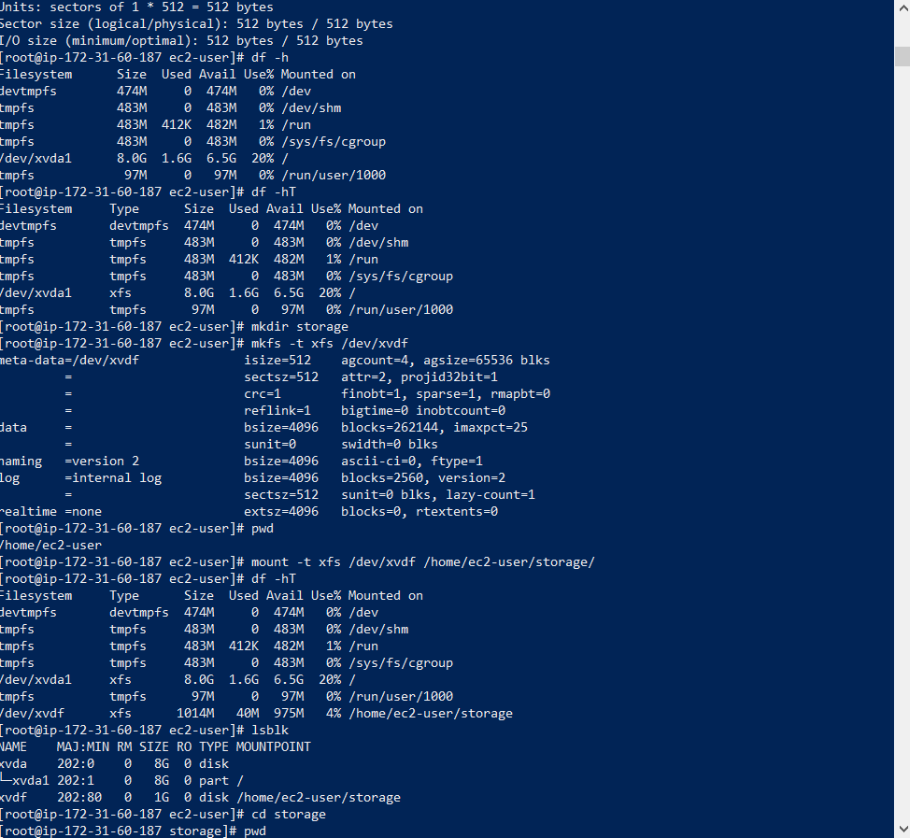

1. Creating a volume from one machine to another machine

1. Snapshot Screenshot Creation
   1. Create a snapshot

* 1. Creation of storage snapshot

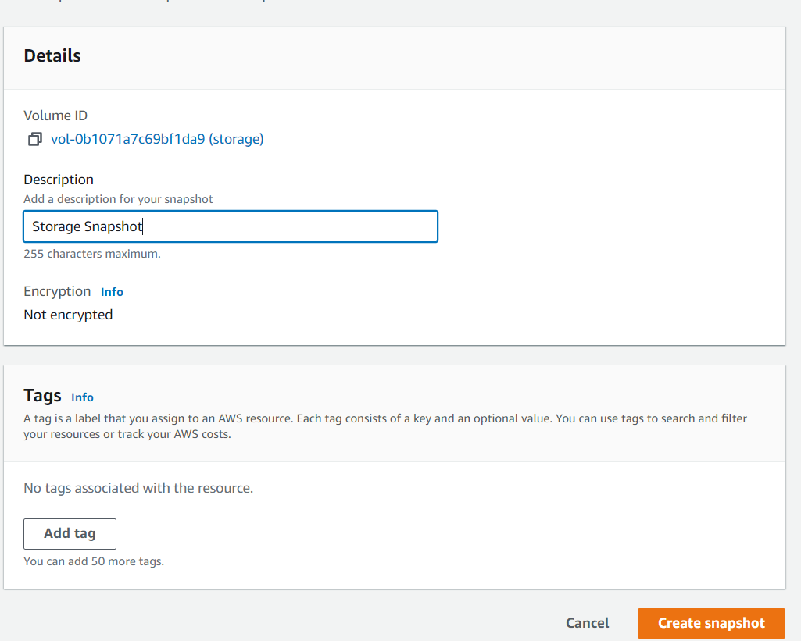

* 1. Storage snapshot created

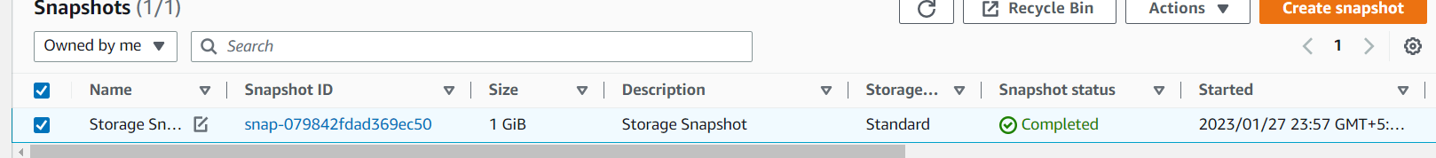

1. AMI(Amazon Machine Image)

* 1. Click on create image

* 1. After click on create image button below is the screenshot

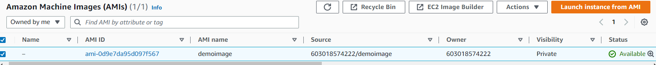

**5. Load Balancer creation:**

Accessing the both EC2 instances using LB

