**Creation of EC2 instance:**

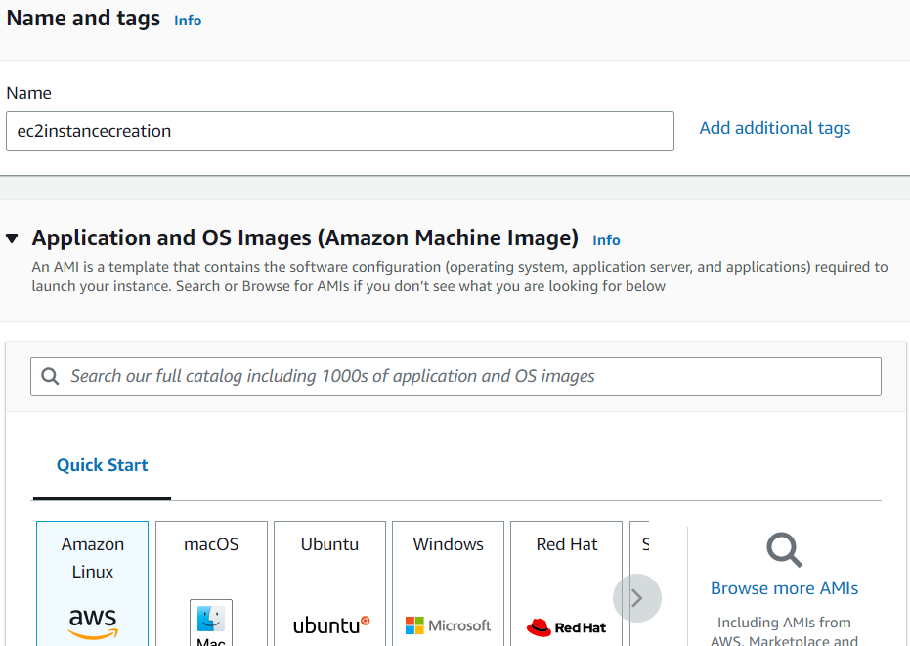

Selection of instance Type and KeyPair

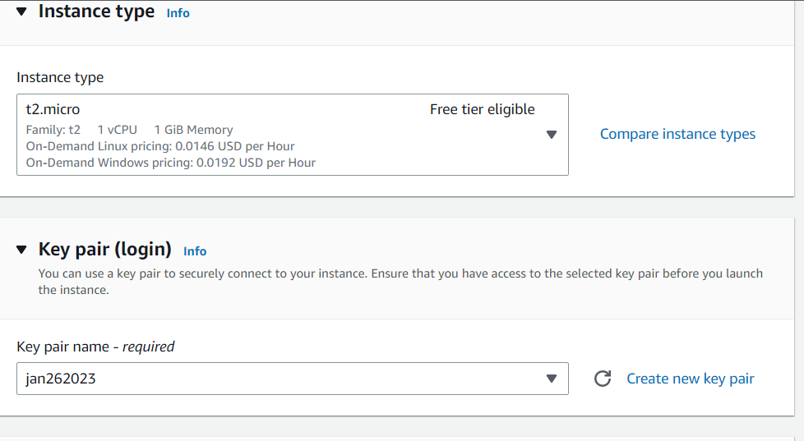

Network Settings

Click on launch Instance button

After Connecting to SSH

**Creation of EBS Storage:**

Steps:

* Create a Volume
* Attach the volume storage to machine
* Make a file system, mount the file system
* Create some files in the new file system
* Fdisk -l
* Create a directory
* mkfs -t xfs <disklocaiton>
* mount -t xfs <disk> <director>

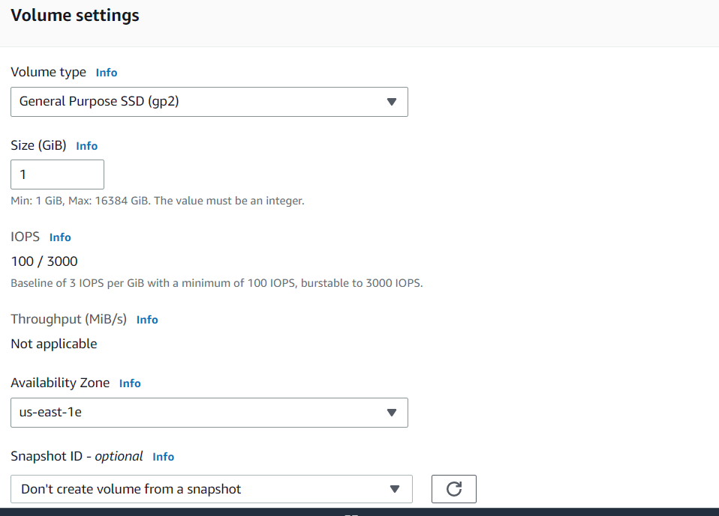

Attach the volume to any EC2 instance

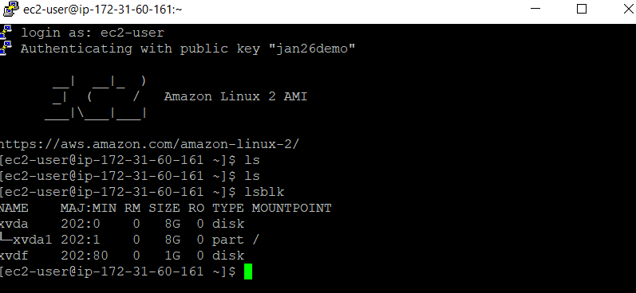

Create a directory and attach the file System

After creating file system and mounting below is the screenshot

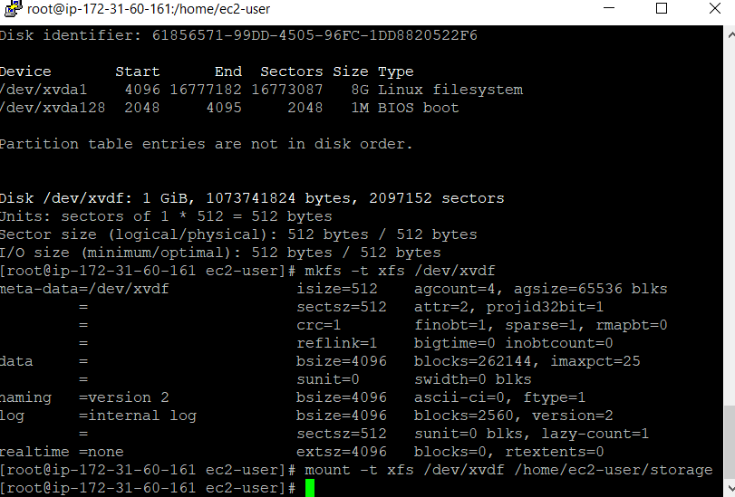

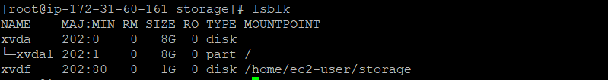

**3. Snapshot Screenshot creation:**

**Creation of snapshot for the custom volume created above**

**Click on create Snapshot**

Snapshot completed for custom volume of 1GB

**4. AMI Creation:**

Click on create image

After click on create image button below is the screenshot

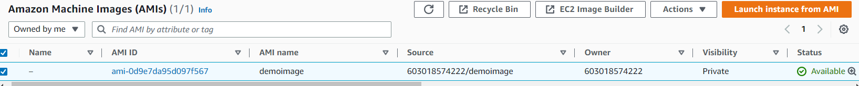

**5. Load Balancer creation:**

Accessing the both EC2 instances using LB

