**VPC :**

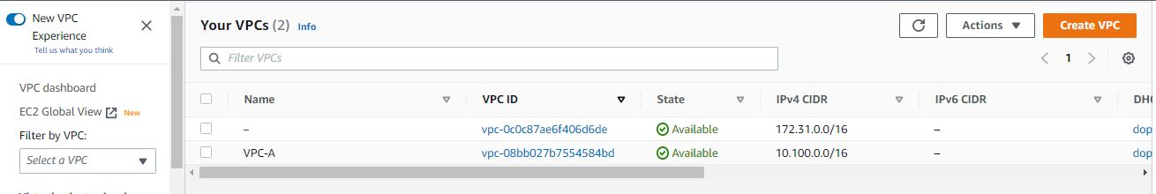

Created VPC in range of 10.100.0.0/16

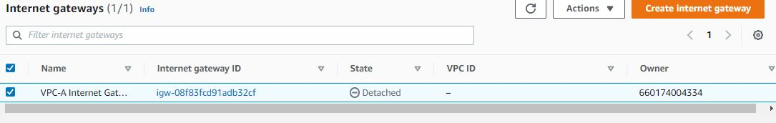

Created Internet Gateway

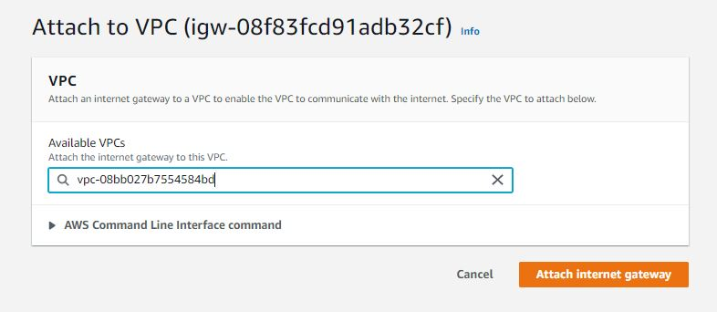

Attaching Internet Gateway to VPC

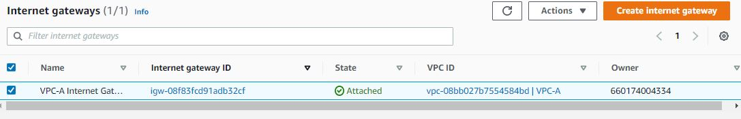

Attached Internet Gateway to VPC

Attached Internet Gateway to VPX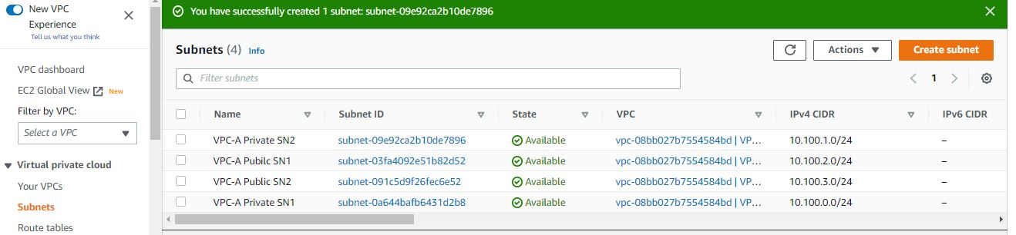

Created 2 Public subnets and 2 Private subnets

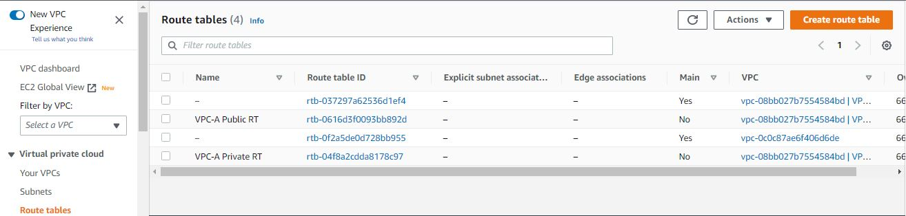

Created 2 Route tables one is Public Route table and one is Private Route table

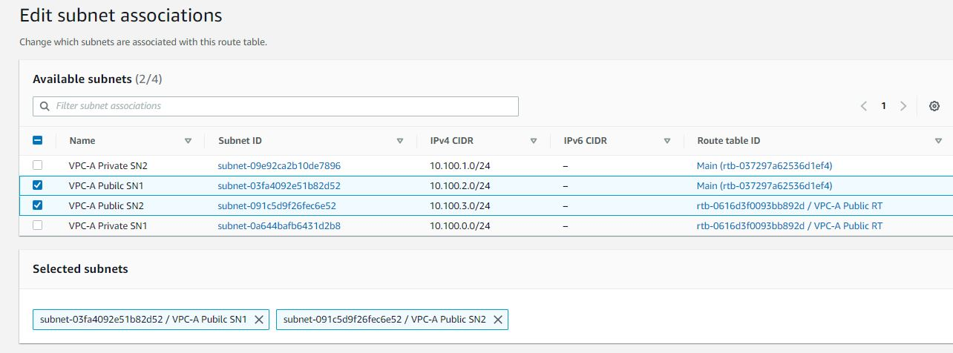

Associated Publc Subnets to Public Rout Table

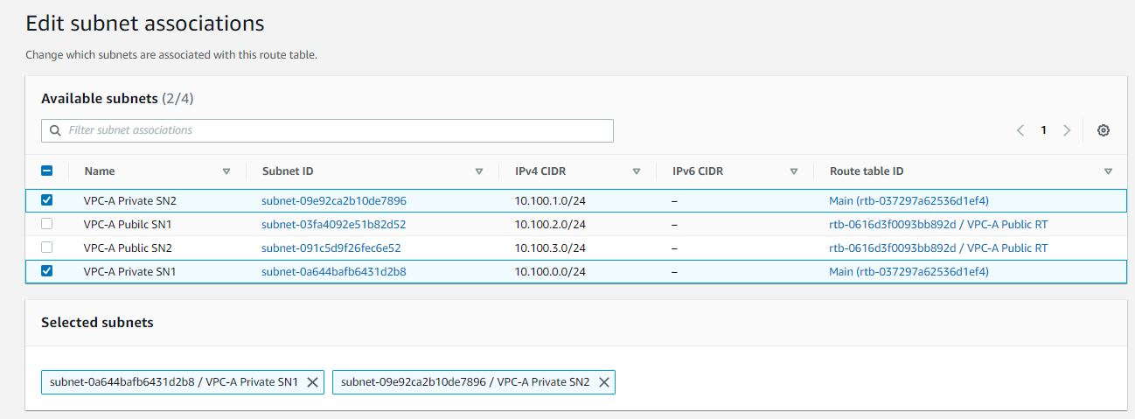

Associated Private Subnets to Private Route Table

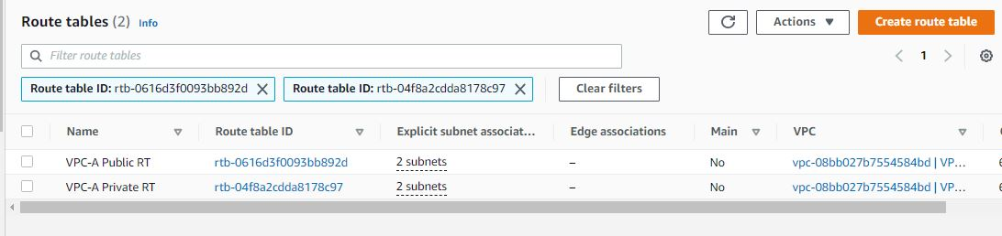

Associated Public Subnets to Public Route Table and Private Subnets to Private Route Table

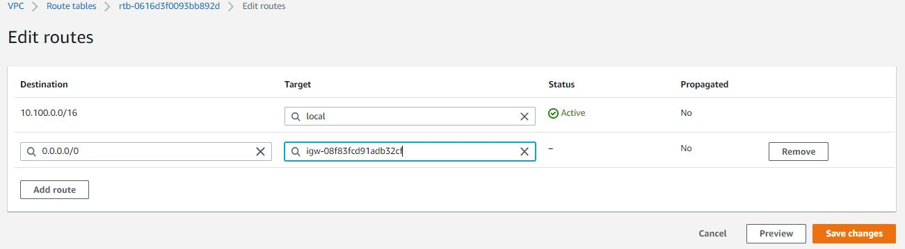

Routing Internet Gateway to Public Route Table

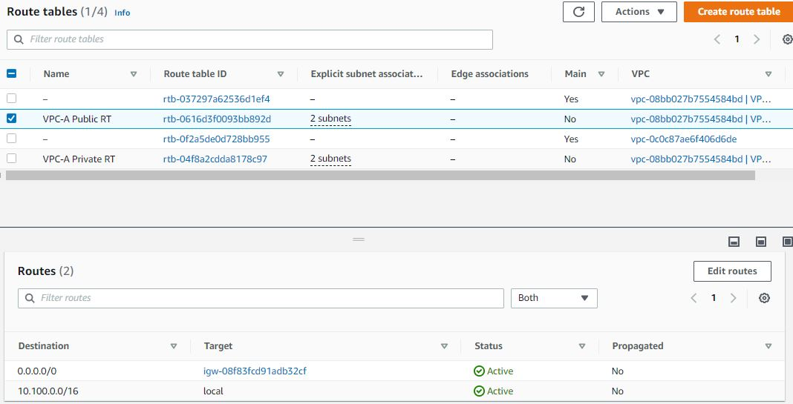

Routed Internet Gateway to Public Route Table

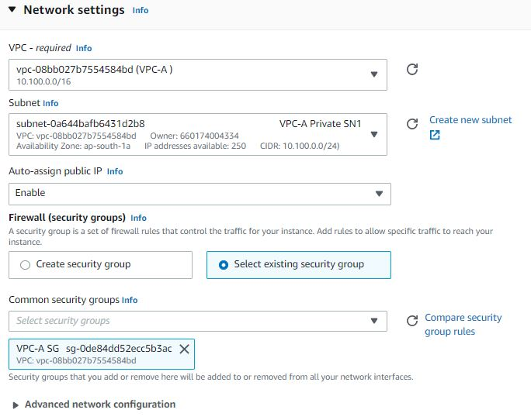

Creating Instance with Private subnet

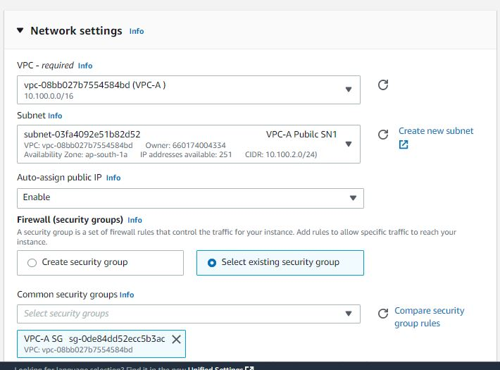

Creating Instance with Public Subnet

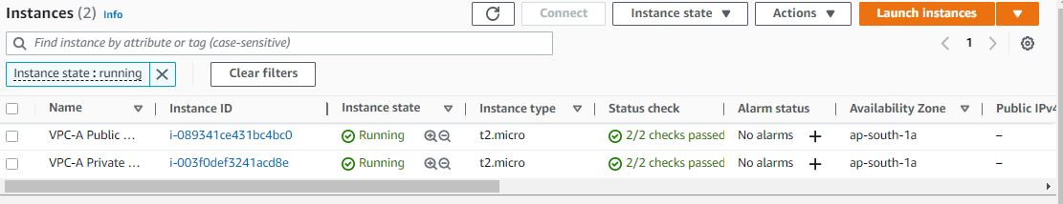

Created Instances with Public and Private Subnets

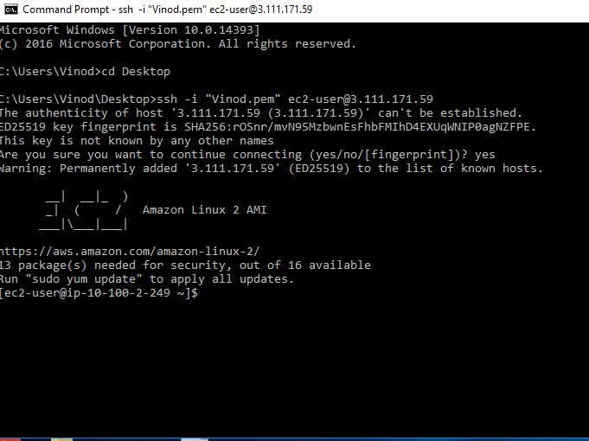

Logged in to Public subnet Machine

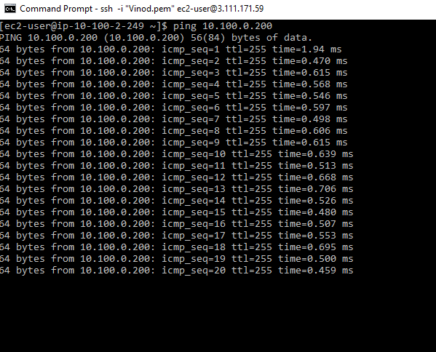

Pinging to Private subnt, It’s working

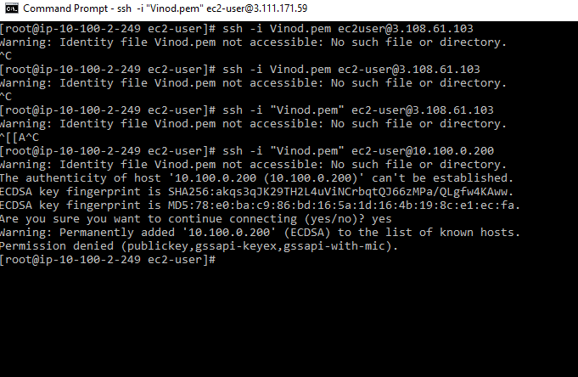

Trying to connect private Subnet it’s getting permission denied error for public key

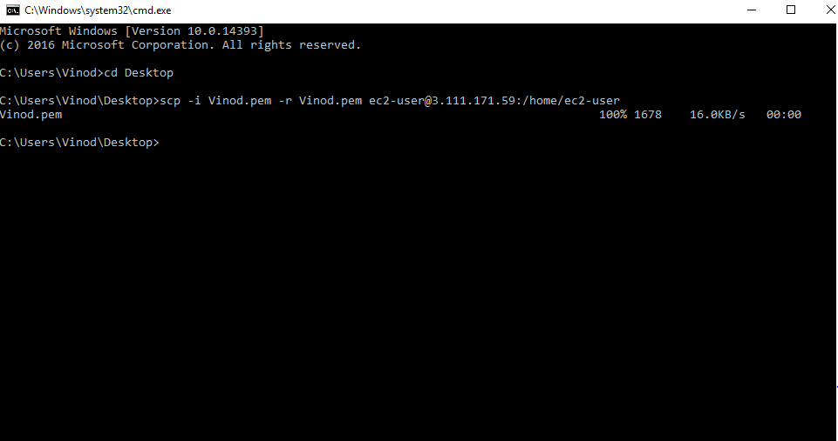

Copied Keypair in Public Subnet user “scp” command

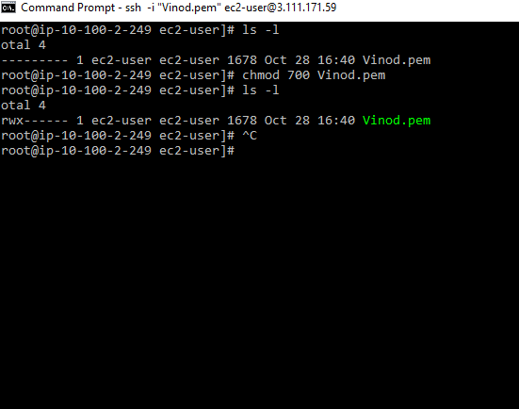

Given All Permissions to key using “chmod 700” command

Trying to connect Private subnet in public subnet

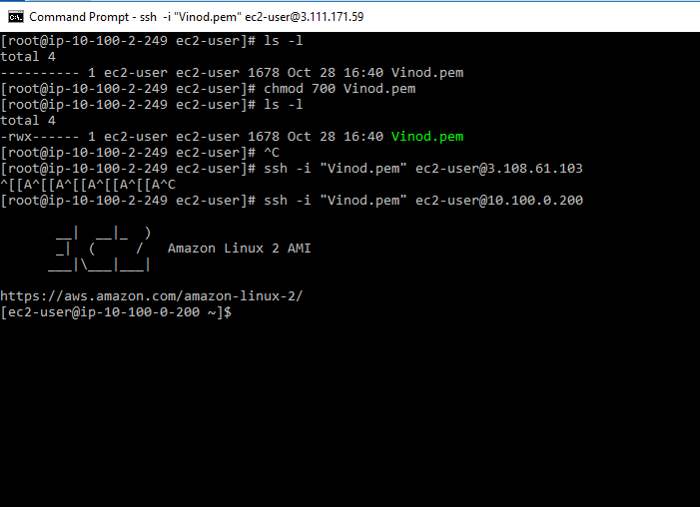

Now it’s Connected Private subnet in public Subnet

For Giving internet access to Private subnet creating NAT Gateway

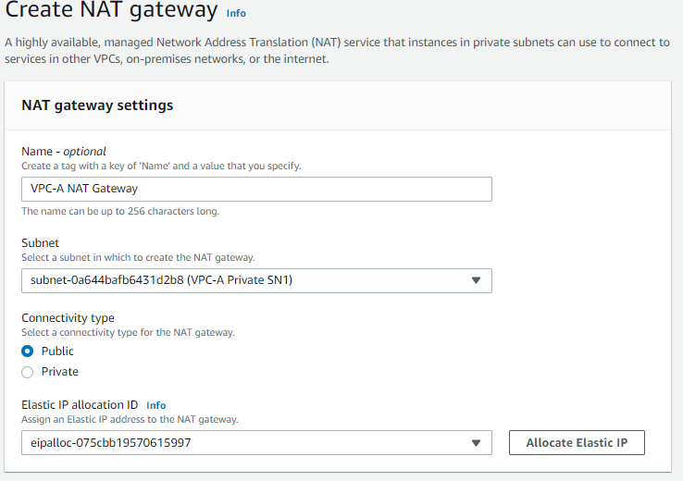

**VPC** **Peering :**

For VPC Peering, Creating another VPC called VPC-B in the range of 10.200.0.0/16

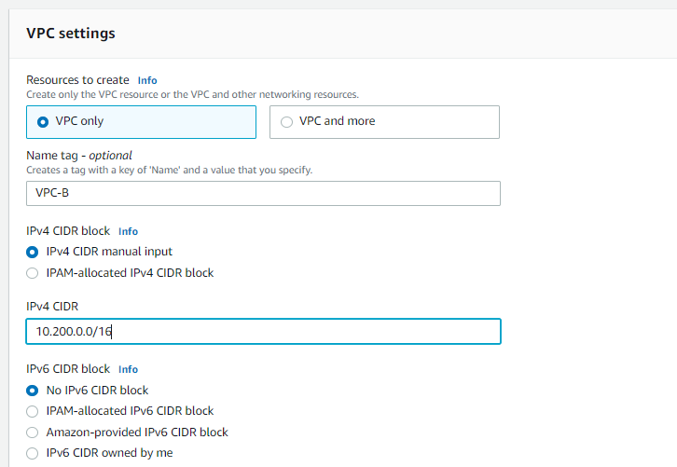

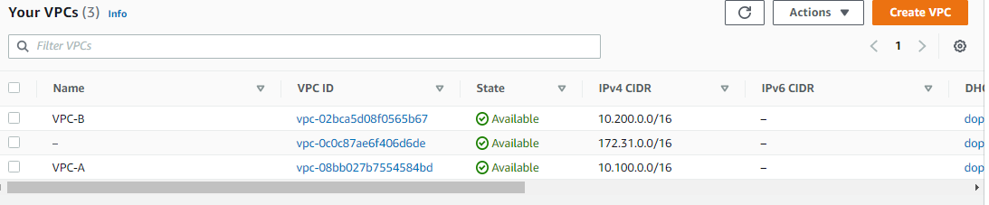

Created VPC-B

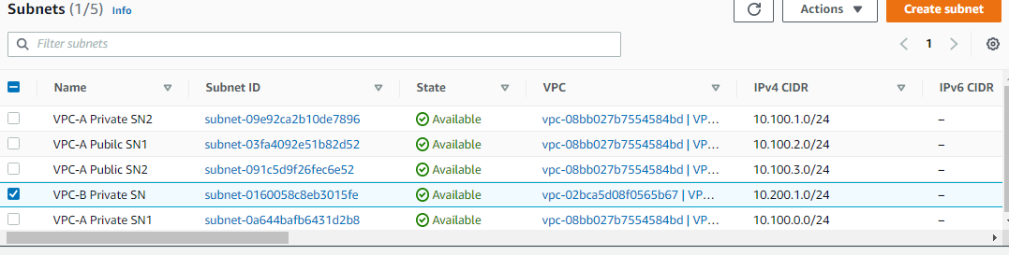

Created Private subnet in VPC-B

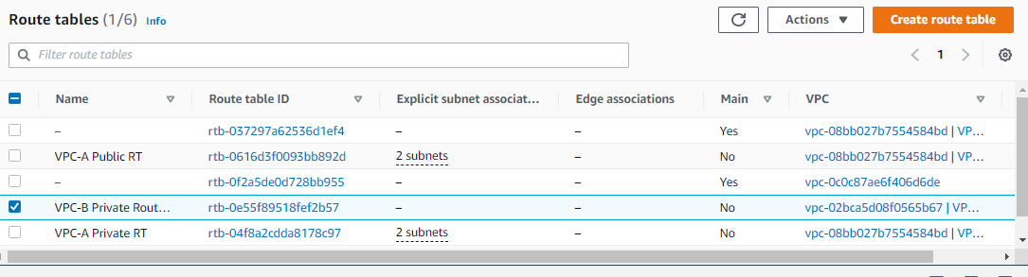

Created Private Route Table

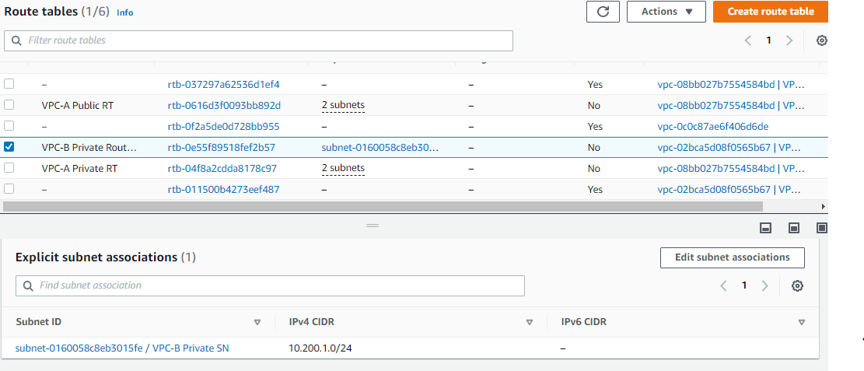Associated Private subnet to Route Table

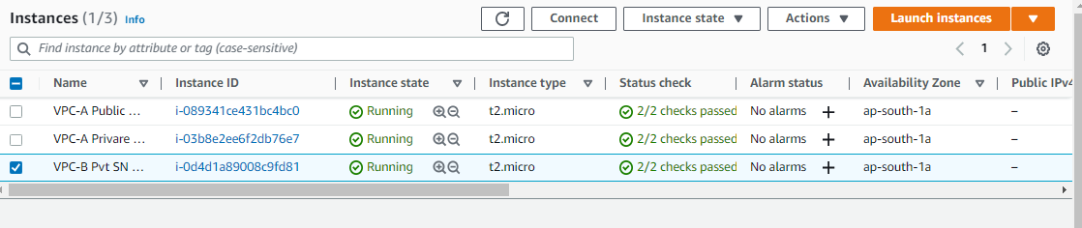

Created Instance in VPC-B Private Subnet

Creating Peering Connection

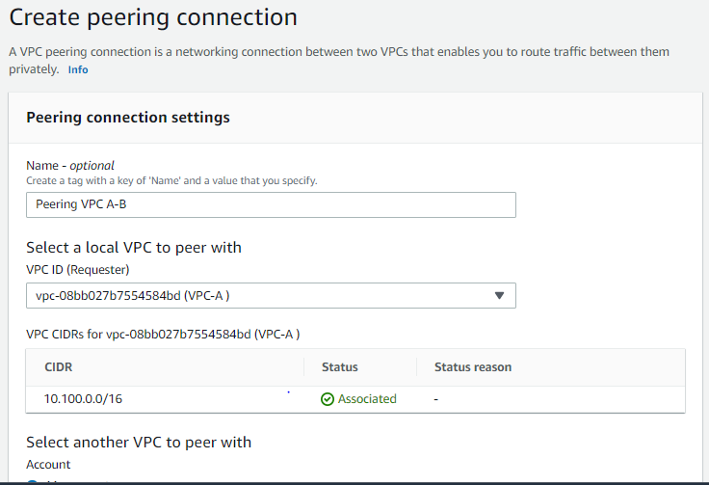

Created peering Connection But need accept the peering connection

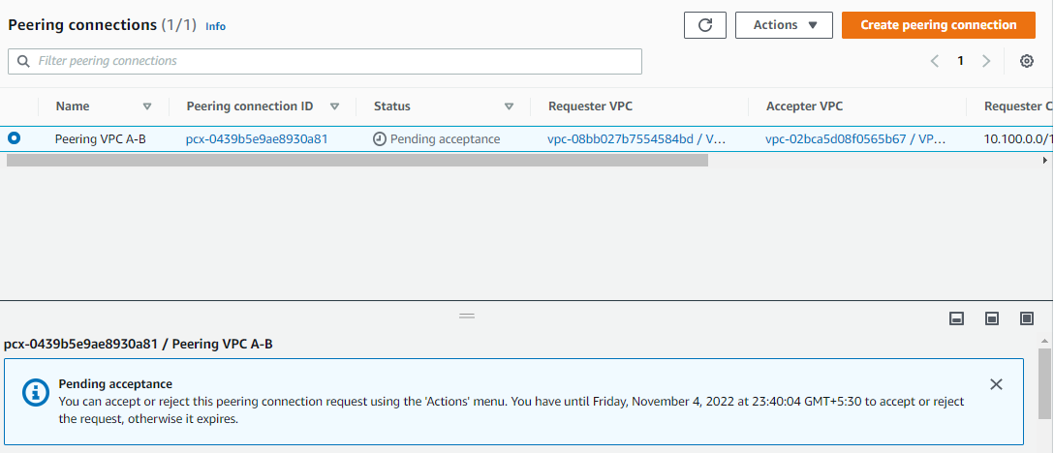

For accept the peering connection,

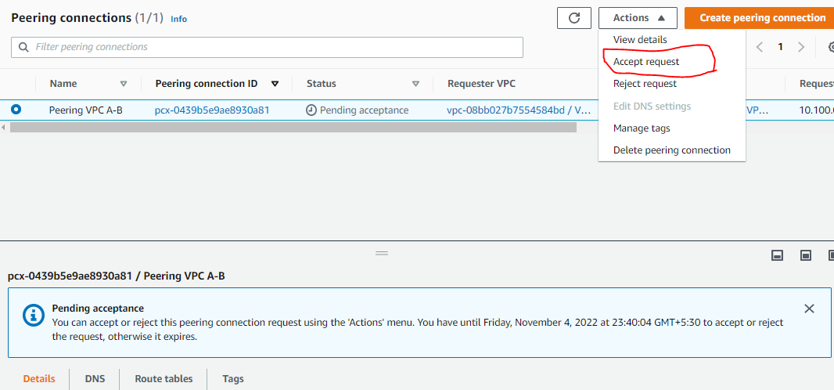

Select the Peering connction Go on Actions, Accept request

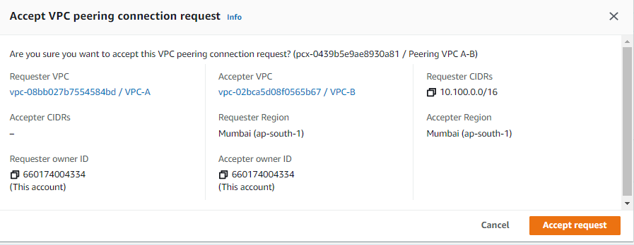

Click on Accept request

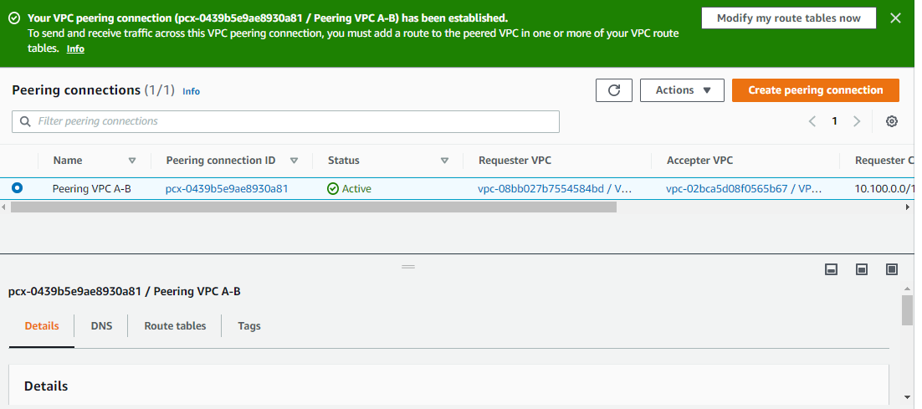

Now VPC Peering is Active

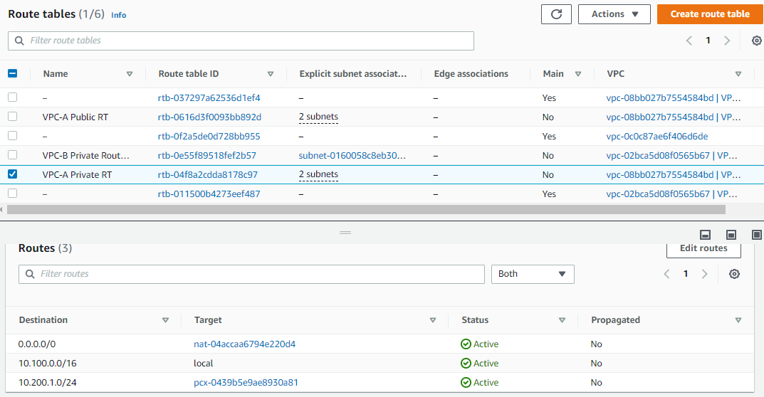

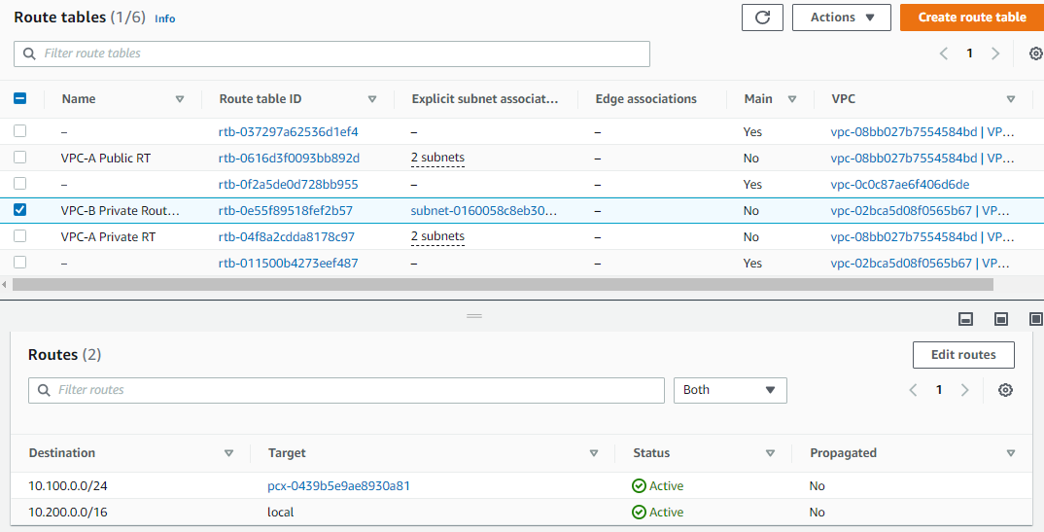

Now Trying Ping or ssh from VPC-A Private subnet to VPC-B Private subnet

For need to connect Copy keypair from VPC-A Public subnet to VPC-A private subnet using “scp” command

Then Ping VPC-B private Subnet

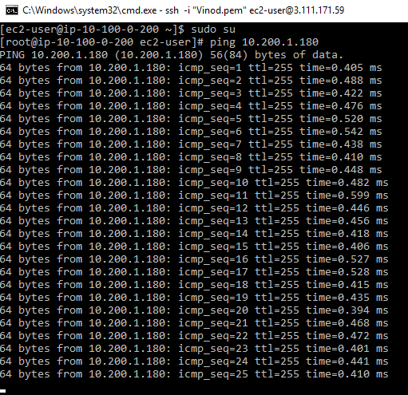

It’s Pinging

Now Try to connect using ssh

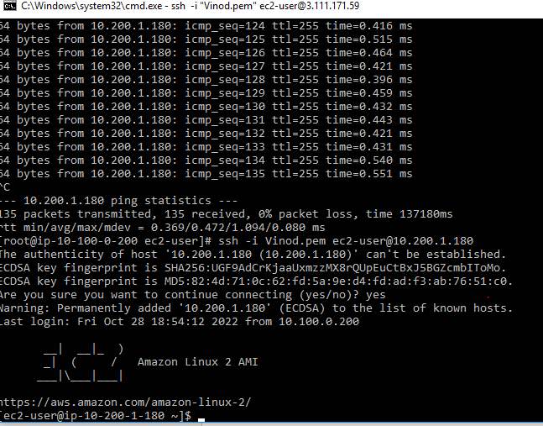

It’s connected now