Question 1:
Number game between user and computer. The user starts by entering either 1 or 2 or 3 digits starting from 1 sequentially. The computer can return either 1 or 2 or 3 next digits in sequence, starting from the max number played by the user. User enters the next 1 or 2 or 3 next digits in sequence, starting from the max number played by the computer. Whoever reaches 20 first wins the game.
Note:
- the numbers should be in sequence starting from 1.
- minimum number user or computer should pick is at least 1 digit in sequence
- maximum number user or computer can pick only 3 digits in sequence
Example 1:
Player: 1 2
Computer played: [3, 4]
Player: 5 6 7
Computer played: [8, 9]
Player: 10
Computer played: [11, 12, 13]
Player: 14 15
Computer played: [16, 17, 18]
Player: 19 20
Player Wins!!!

Example 2:
Player: 1
Computer played: [2, 3]
Player: 4 5
Computer played: [6, 7, 8]
Player: 9 10
Computer played: [11]
Player: 12
Computer played: [13]
Player: 14 15
Computer played: [16]
Player: 17 18
Computer played: [19, 20]
Computer Wins!!!

Question 2:
Develop a function called ncr(n,r) which computes r-combinations of n-distinct object . use this function to print pascal triangle, where number of rows is the input

Question 3:
Read a list of n numbers during runtime. Write a Python program to print the repeated elements with frequency count in a list.

Example :
Input:- [ 2,1,2,3,4,5,1,3,6,2,3,4]
Output:-
Element 2 has come 3 times
Element 1 has come 2 times
Element 3 has come 2 times
Element 4 has come 2 times
Element 1 has come 1 times
Element 6 has come 1 times
Question 4:-
Develop a python code to read matric A of order 2X2 and Matrix B of order 2X2 from a file and perform the addition of Matrices A & B and Print the results.
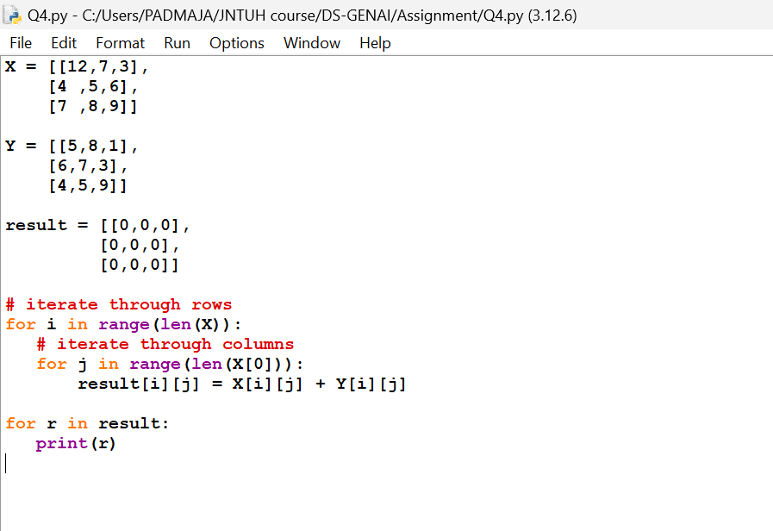
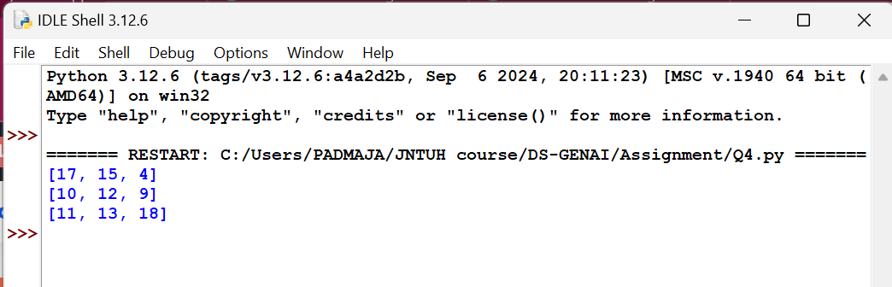
Question 5:-
Write a program that overloads the + operator so that it can add two objects of the class Fraction.
Fraction can be considered of the for P/Q where P is the numerator and Q is the denominator

