1. Python Program to check Armstrong Number?

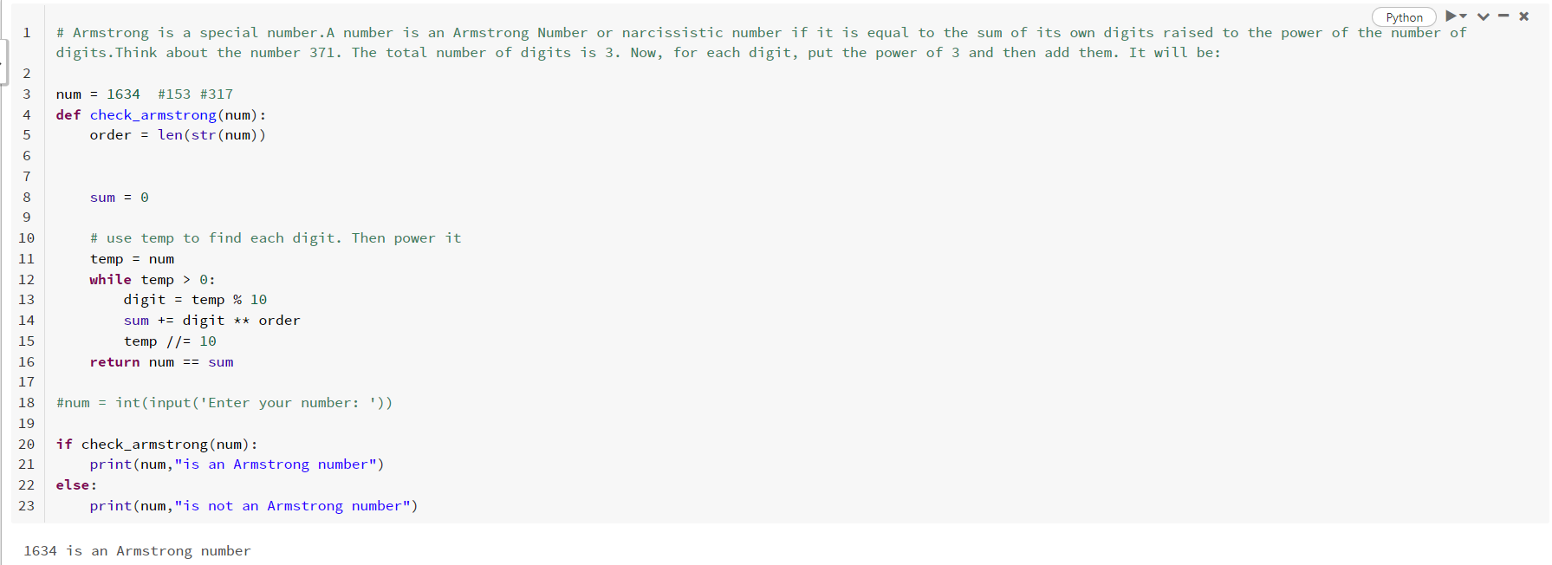

1. Python Program for How to check if a given number is Fibonacci number?

