JNTUH ASSIGNMENT 8

1. What is the most frequent internet activity time of the day?

A: its between 12 noon to 12 o’ clock in the morning .

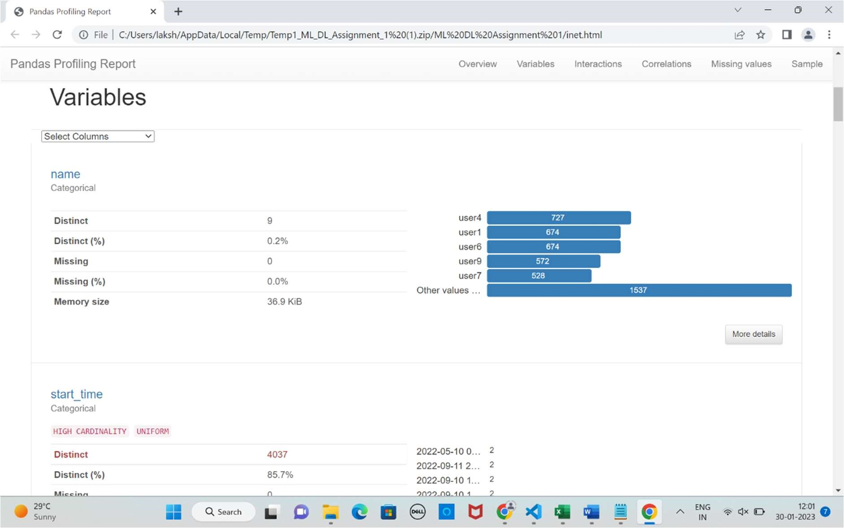

THE FOLLOWING IS THE FREQUENCIES OF PEOPLE’S START TIME (INTERNET ACCESS TIME)

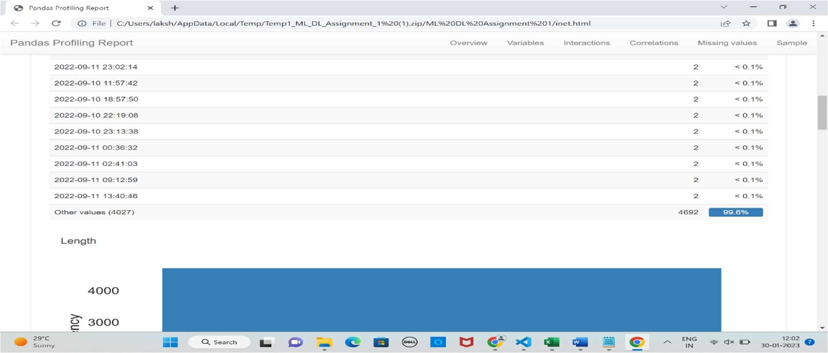

1. HOW often the IP changes ?

A: every 14 days there is a DHCP lease renewal takes place .

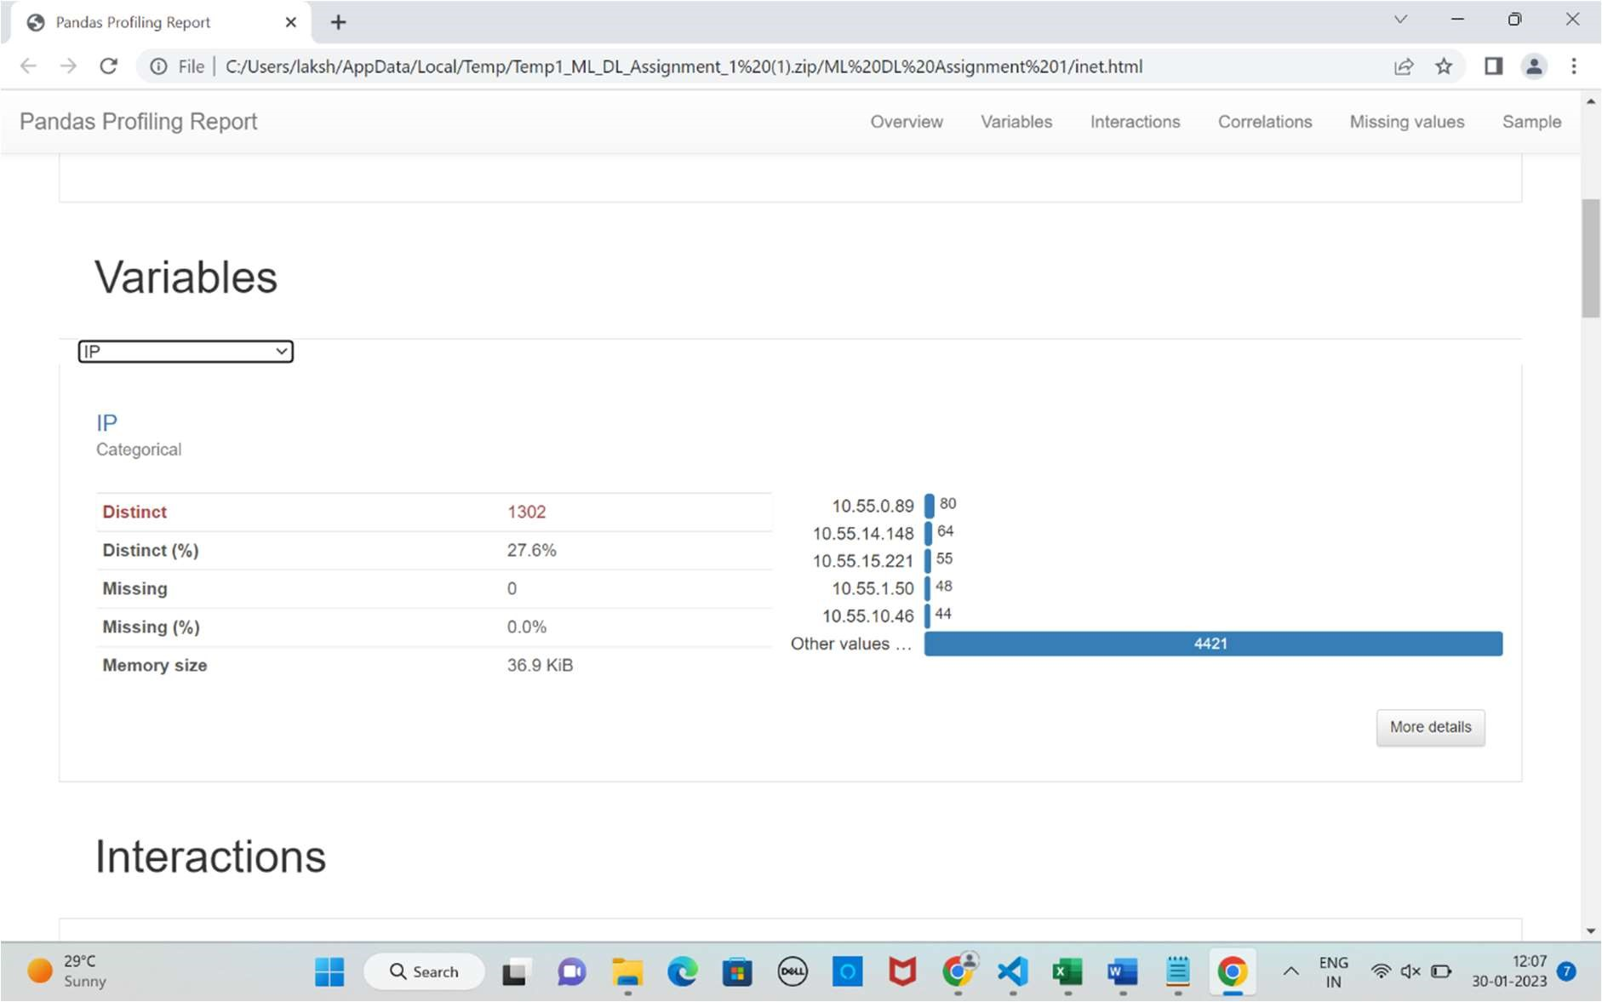

1. How often the device is changed ?

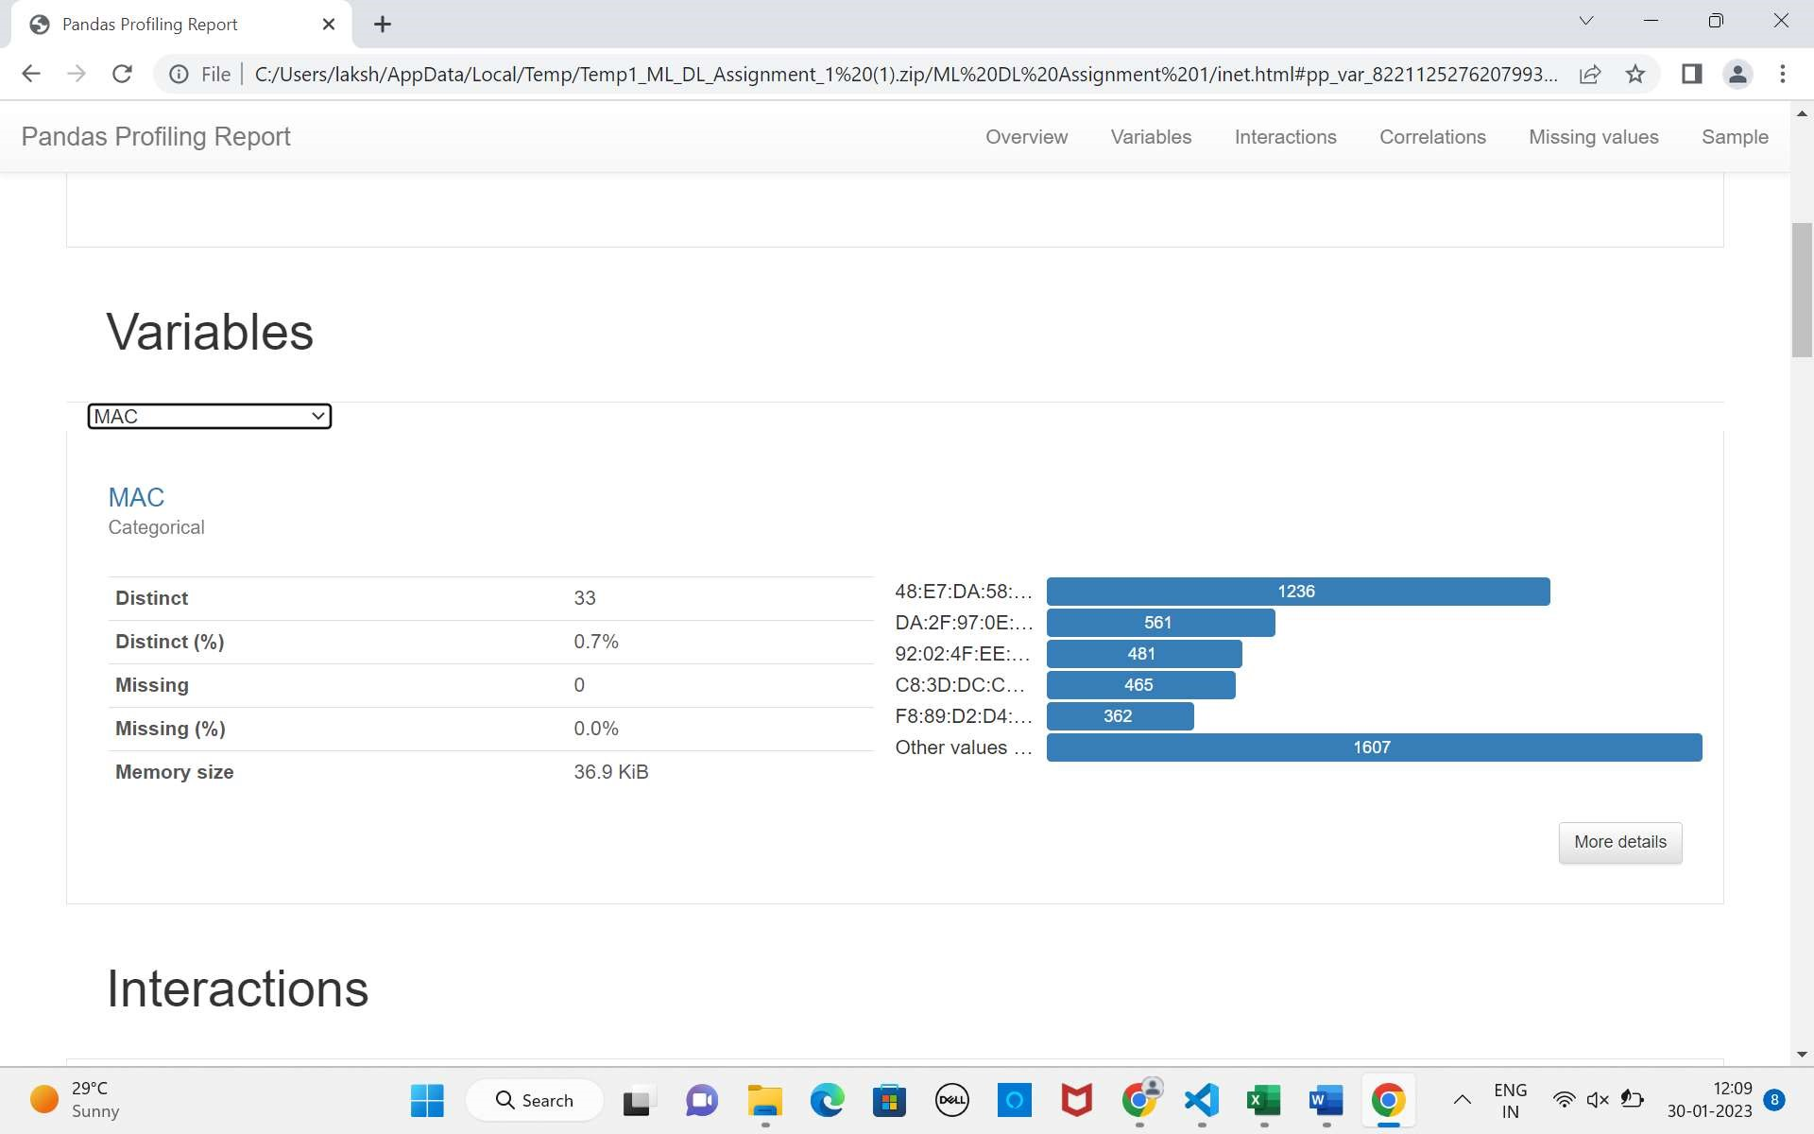

1. Usage of internet

