1.

def check(n):

    if n % 2 == 1:

        print("Weird")

    elif 2 <= n <= 5:

        print("Not Weird")

    elif 6 <= n <= 20:

        print("Weird")

    else:

        print("Not Weird")

n = int(input("Enter an integer: "))

check(n)

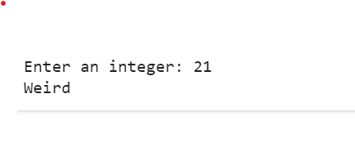

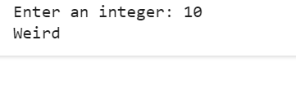

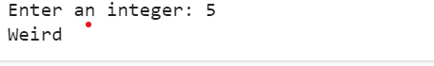

2.

def find_runner_up_score(scores):

    sorted_scores = sorted(scores, reverse=True)

    unique_scores = sorted(set(sorted_scores), reverse=True)

    runner_up_score = unique_scores[1]

    return runner_up_score

n = int(input("Enter the number of scores: "))

scores = list(map(int, input("Enter the scores separated by space: ").split()))

runner_up_score = find_runner_up_score(scores)

print("The runner-up score is:", runner_up_score)

