1.

def second_lowest_grade_students(student_grades):

    sorted_grades = sorted(student_grades, key=lambda x: x[1])

    second_lowest_grade = sorted(set(grade for name, grade in sorted_grades))[1]

   second_lowest_students = [name for name, grade in sorted_grades if grade == second_lowest_grade]

    second_lowest_students.sort()

    for student in second_lowest_students:

        print(student)

n = int(input("Enter the number of students: "))

student_grades = []

for _ in range(n):

    name = input("Enter student name: ")

    grade = float(input("Enter student grade: "))

    student_grades.append([name, grade])

second_lowest_grade_students(student_grades)

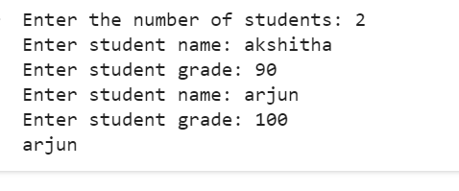

2.

def two_sum(nums, target):

    num_indices = {}

    for i, num in enumerate(nums):

        complement = target - num

        if complement in num_indices:

            return [num_indices[complement], i]

        num_indices[num] = i

nums = list(map(int, input("Enter the list of integers separated by space: ").split()))

target = int(input("Enter the target sum: "))

result = two_sum(nums, target)

if result is not None:

    print("Indices of the two numbers:", result)

else:

    print("No solution found.")

