**How do we create & connect a amazon Linux AWS EC2 machine:**

1: Login into the aws console page

2. Once you login go to Services.

Services -> Compute -> EC2

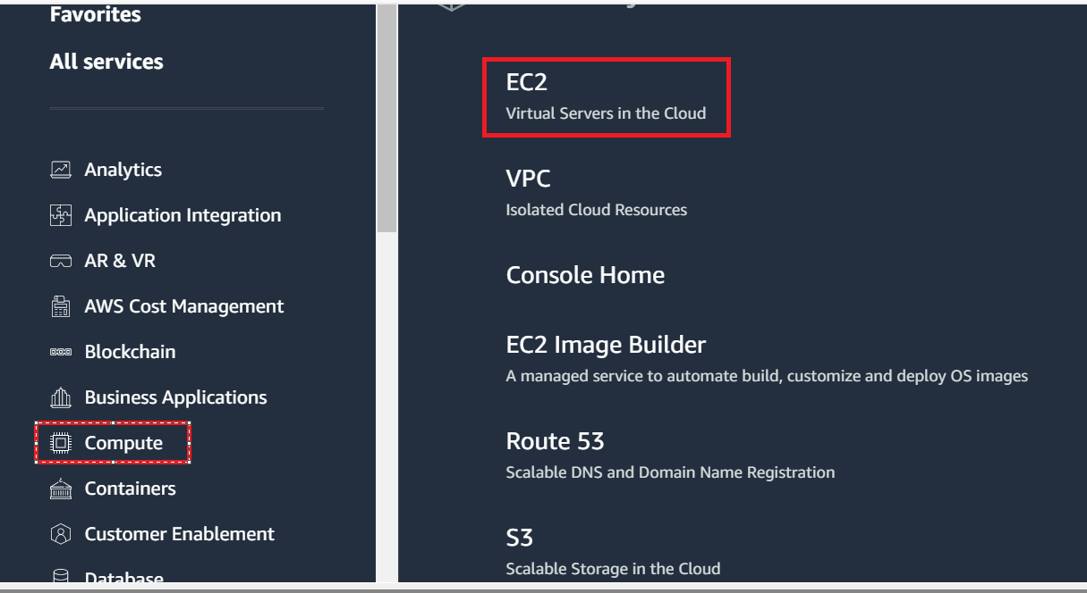

3. Then go to instances and click on Launch Instance:

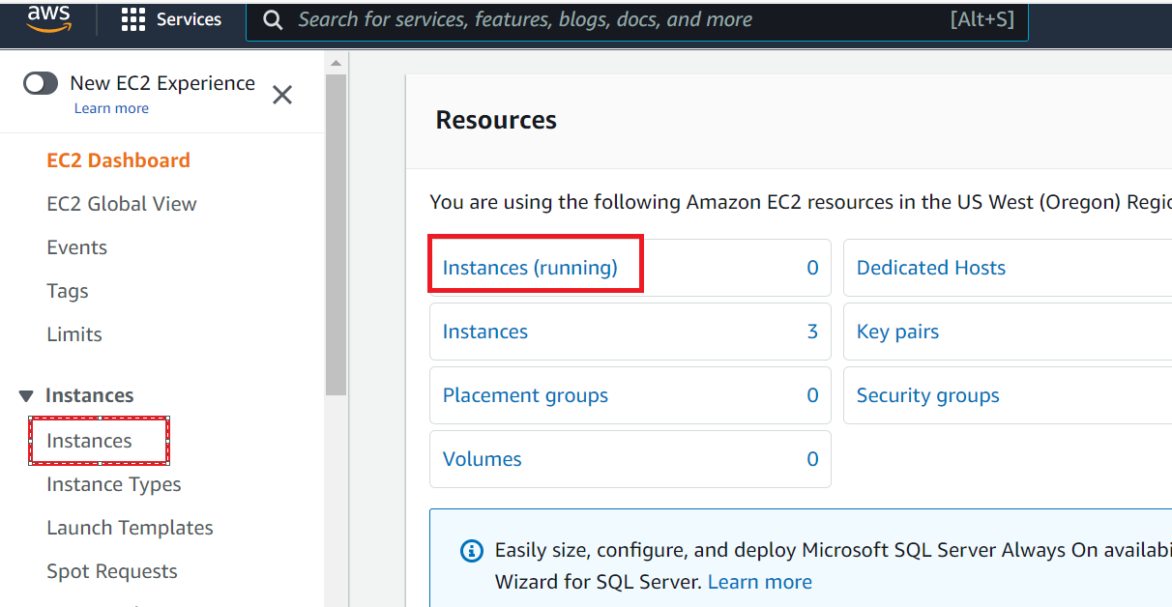

4. Then click on Launch instance option:

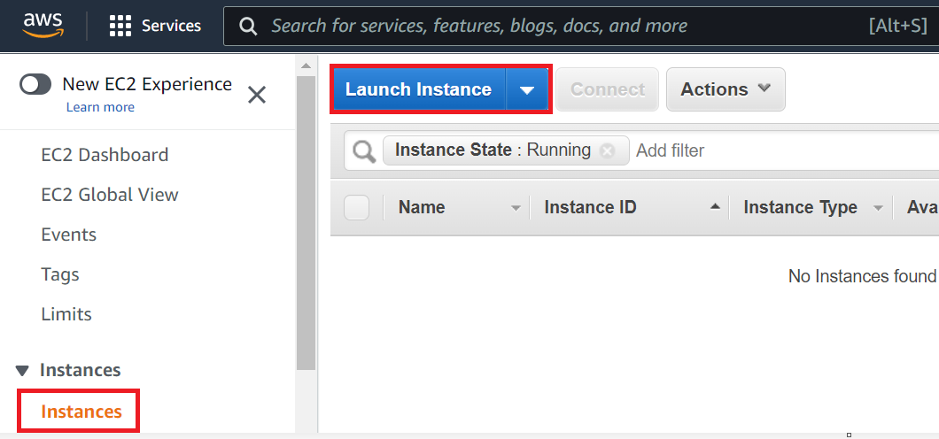

5. Then give the name to the instance machine:

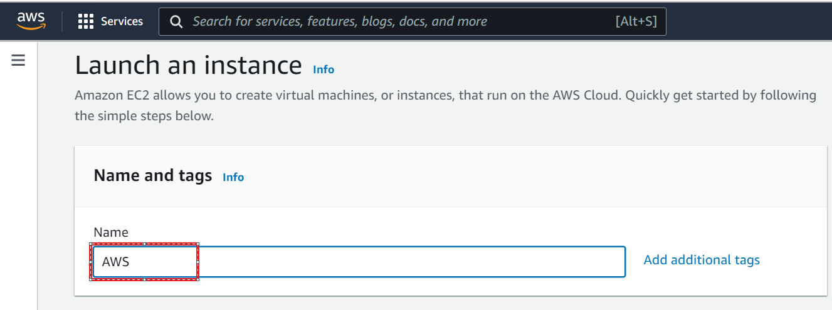

6. Then select OS Image and the version:

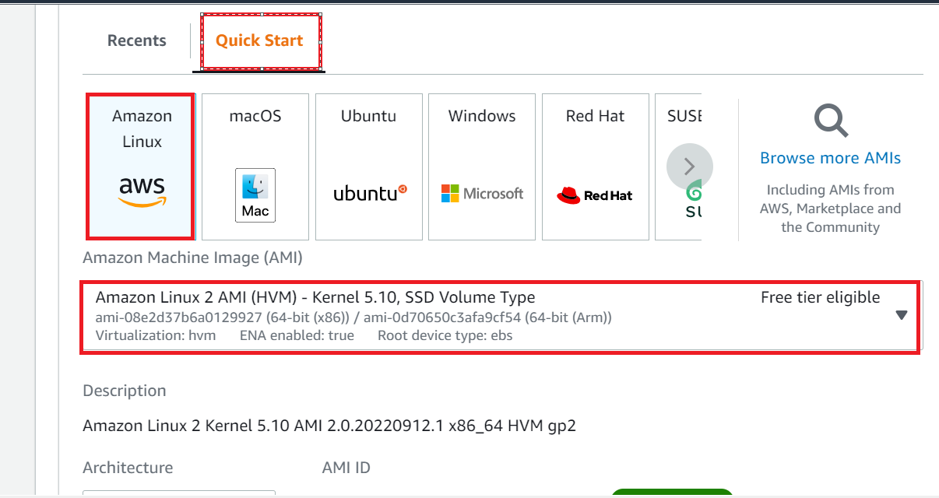

7. Under the Instance type : Select – t2.micro machine

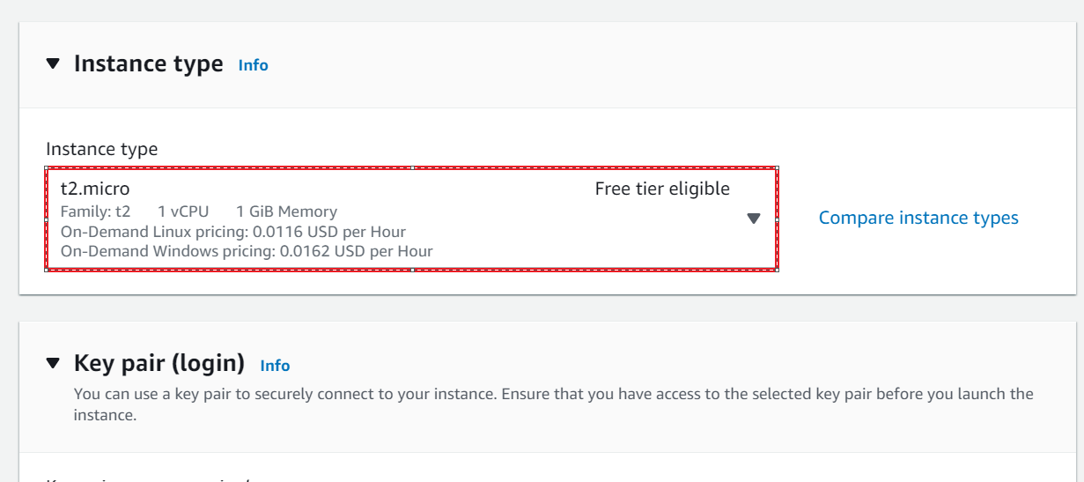

8. Then select the keypair, if you don’t have the keypair please click on “create new keypair”

If you have already you can also use the existing key pair

Note: On the below screenshot, If you already have a key pair we can use the existing keypair or create a new:

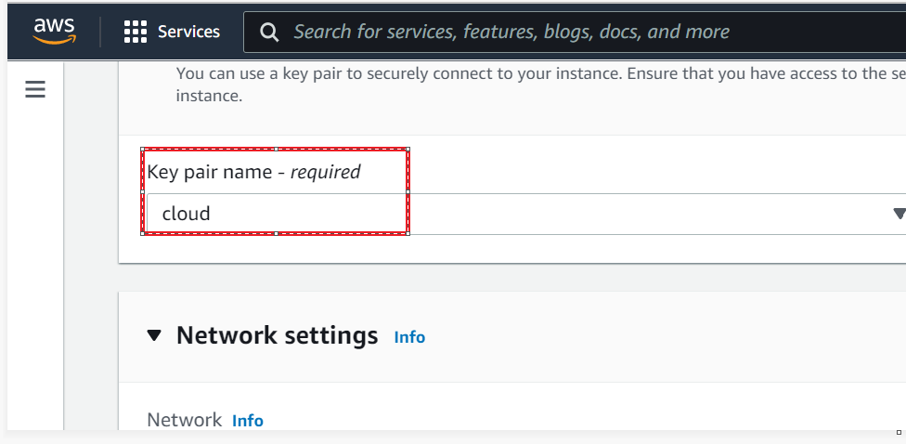

9. Under network settings, use the existing network and go to the nextstep:

10. Under Configure storage, please provide your required configure storage: 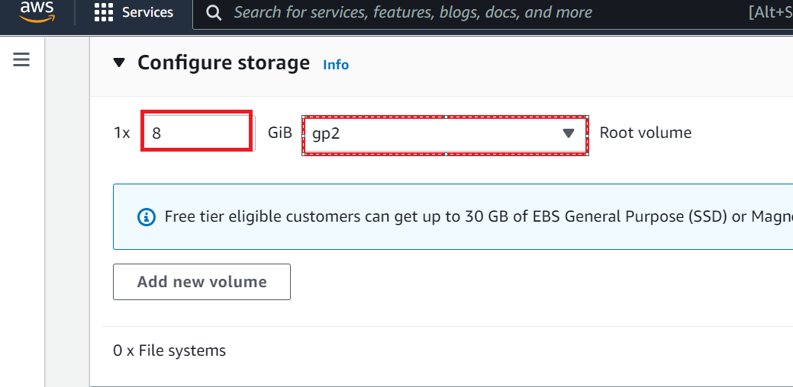

11. Then provide the number of instances you required:

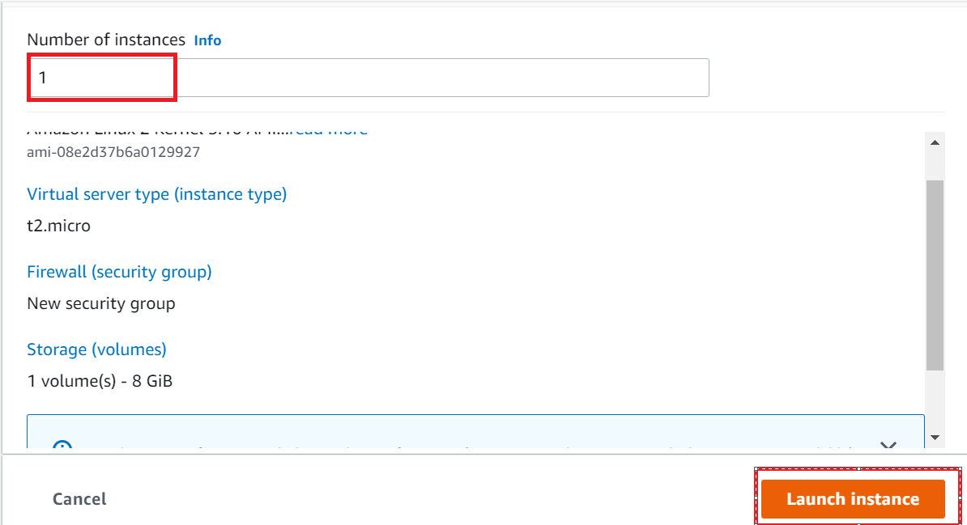

12. Then go to EC2 instances again:

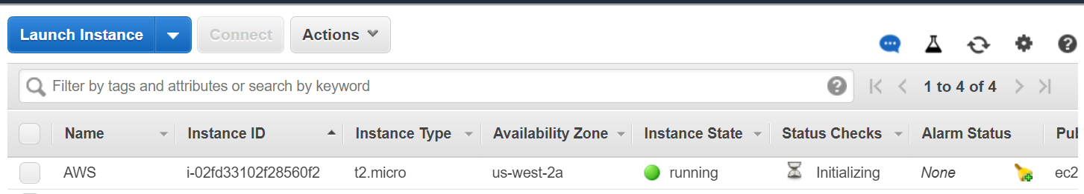

**How do we connect to an EC2 machine:**

Note: Please check to use the new EC2 Interface.

1. Create an EC2 instance, once the instance is created and running:
2. Then select the instance and then click on Connect:

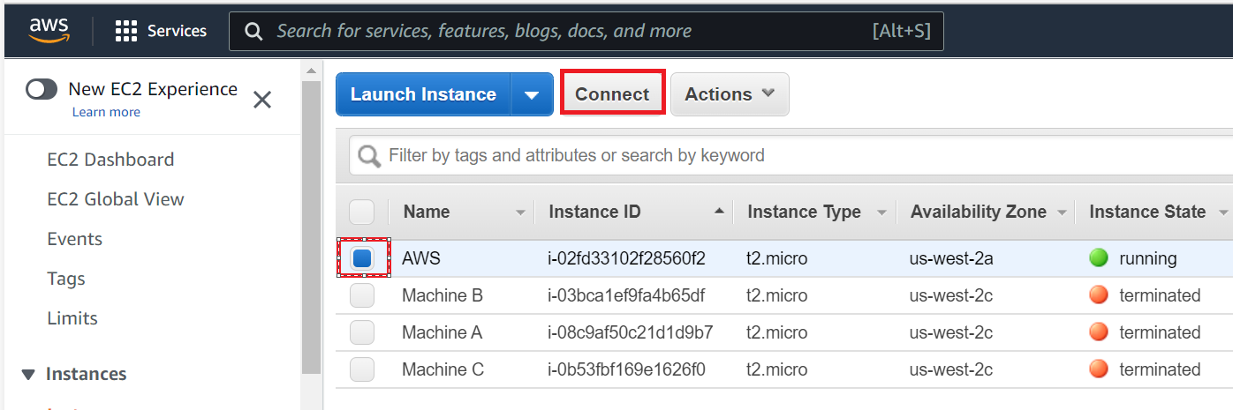

1. Then go to SSH Client and copy the command under example:

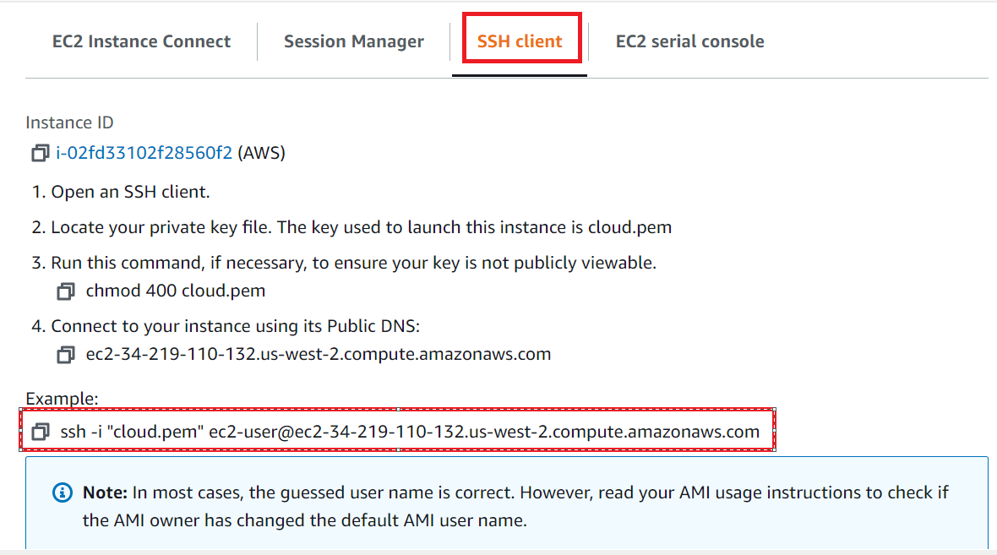

1. Then open the powershell and run as an administrator:

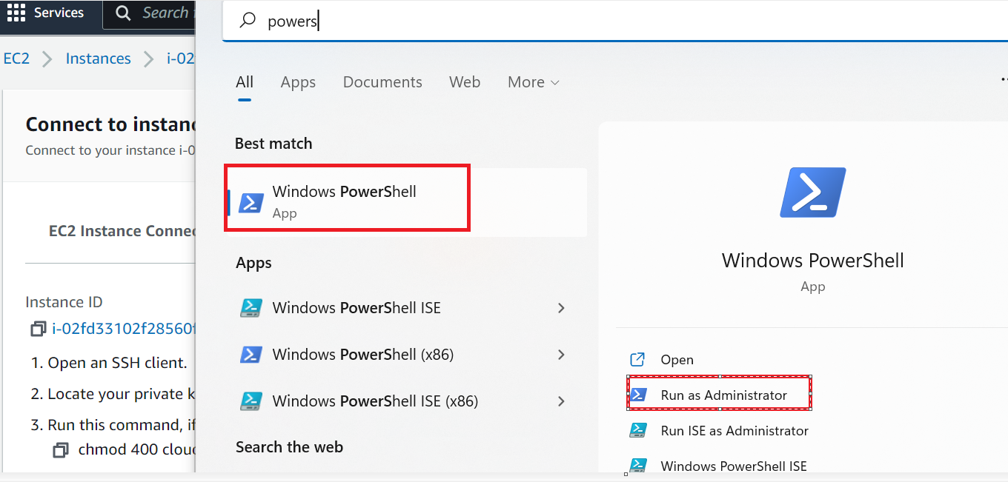

1. In the powershell terminal, then go to the folder where the pem file is located and then give the copied ssh command:

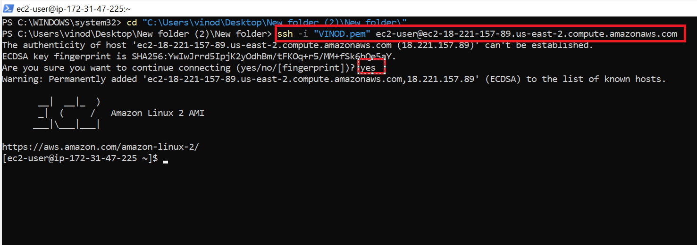

Note: By default we can connect a Linux EC2 machine in multiple ways:

1. Windows Powershell
2. Putty
3. EC2 connect instance (web Interface)
4. Other putty terminals

In the above example, we have used windows powershell to connect for a Linux virtual machine.

**How do we create a keypair:**

1. Go to launch instance -> key pair (login) section and select Create new key pair:

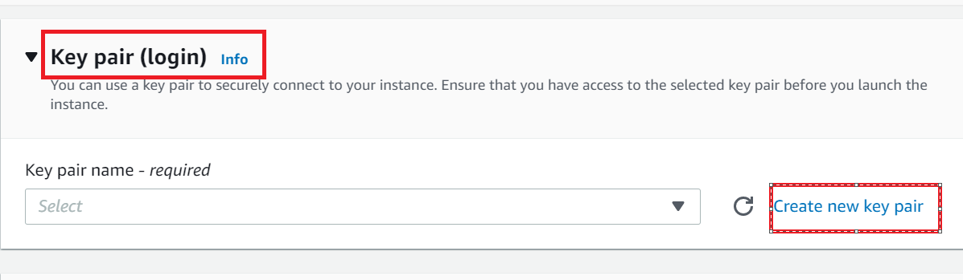

1. Then provide the new key pair name & select key pair type **RSA** and Private key file format **.pem** & click on **Create key pair**

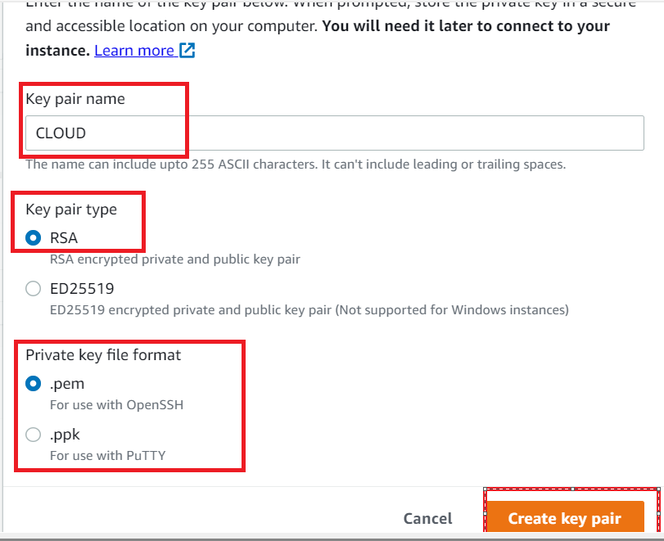

1. Then a new key pair is downloaded.